AI Agents: Functioning, Applications, and Ethical Implications


1. Introduction
Artificial Intelligence (AI) is rapidly evolving beyond tools that merely respond to prompts, towards proactive systems known as AI agents. These agents perceive their environment, make decisions, and execute actions autonomously to achieve defined goals (Russell & Norvig, 2020). The emergence of sophisticated Large Language Models (LLMs) has dramatically accelerated this shift, enabling agents to reason, plan, and interact with digital and physical worlds with unprecedented sophistication. This paradigm promises to revolutionize industries, from automating complex business workflows to accelerating scientific discovery. However, the autonomous nature of these systems introduces significant technical, ethical, and societal challenges that must be proactively addressed.
This report answers the research question: What are the main types and architectures of AI agents, what practical applications do they enable, and what technical, ethical, and regulatory measures are required to ensure their safe deployment? The scope encompasses a primary-level educational overview, covering definitions, technical architectures, real-world applications, and a balanced analysis of benefits and risks. The report concludes with evidence-based recommendations for governance, aiming to provide a foundational understanding for policymakers, technologists, and the informed public.
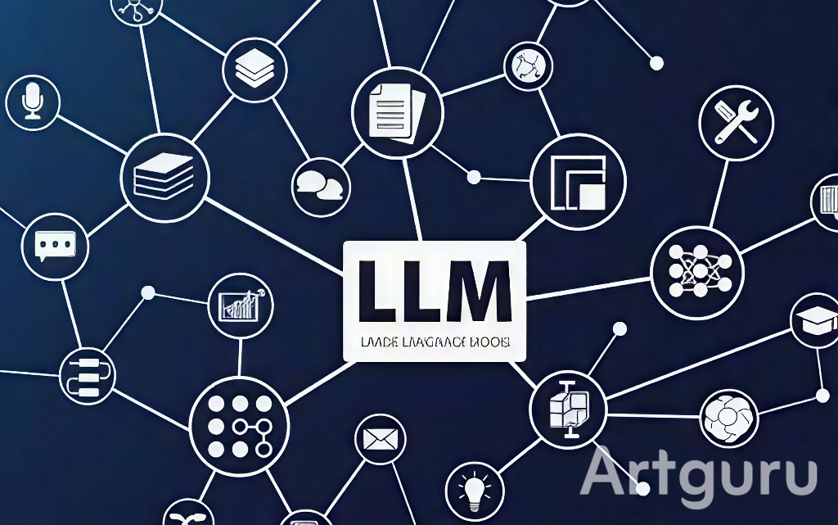

2. Defining AI Agents and Their Architectural Foundations
An AI agent is a system situated in an environment, which it perceives through sensors and upon which it acts using actuators to achieve its objectives (Russell & Norvig, 2020). The complexity of an agent is defined by its architecture, which dictates its capabilities for reasoning, learning, and autonomy.
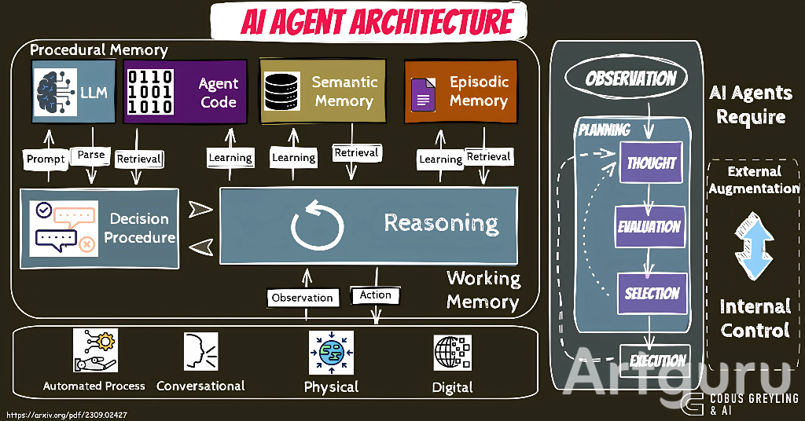

2.1. From Simple Reflex to Goal-Oriented and Learning Agents
AI agents can be categorized along a spectrum of increasing sophistication. The simplest are reflex agents, which map perceptions directly to actions using condition-action rules, with no internal state or memory. Model-based reflex agents maintain an internal state to track aspects of the world not directly perceived, allowing for more robust decision-making. More advanced are goal-based agents, which consider future actions and their outcomes to achieve a specific objective. These agents, often powered by LLMs, can engage in reasoning and planning chains (e.g., "Chain of Thought") to break down complex tasks (Wang et al., 2023). The most advanced category is the learning agent, which incorporates a "learning element" that allows it to improve its performance based on feedback from a "critic" and past experiences stored in a "knowledge base." This enables continuous adaptation to new environments and tasks.

2.2. Core Architectural Components: Perception, Reasoning, and Action
A generalized architecture for a modern AI agent, particularly one built on an LLM, consists of several integrated components. The Perception Module ingests information from its environment, which can be digital (databases, APIs, user interfaces) or physical (sensors, cameras). This information is processed and structured for the Reasoning and Planning Engine, typically an LLM. This engine interprets the goal, breaks it down into a sequence of sub-tasks (a "plan"), and makes decisions. The Action Module then executes this plan by invoking tools or actuators, such as calling an API, controlling a robotic arm, or typing on a keyboard. Finally, a Feedback Loop allows the agent to observe the results of its actions and adjust its plan accordingly, enabling iterative task completion (Xi et al., 2023).

3. Practical Applications Across Industries
The autonomous, goal-directed nature of AI agents enables them to tackle complex, multi-step tasks that were previously the exclusive domain of human labor. Their applications are proliferating across diverse sectors.

3.1. Enterprise and Creative Automation
In the enterprise, AI agents are being deployed to automate intricate, knowledge-intensive workflows. For instance, an agent can be tasked with end-to-end customer onboarding: retrieving data from submitted forms, running credit checks via APIs, generating personalized welcome documents, and scheduling a follow-up call—all without human intervention. A survey by MGI (2023) found that AI-enabled automation could address up to 30% of the hours currently worked in the U.S. economy, largely through the automation of complex decision-making and management tasks. In the creative and software domains, agents can act as autonomous researchers, synthesizing information from multiple web sources to produce comprehensive reports, or as coding assistants that can complete entire software features from a high-level user description.

3.2. Scientific Research and Personal Assistance
In scientific research, AI agents are emerging as powerful collaborators. They can autonomously navigate scientific literature, form hypotheses, design simulation experiments, analyze results, and even draft sections of a research paper. This has the potential to drastically accelerate the pace of discovery in fields like drug development and materials science. On a personal level, advanced AI agents are evolving beyond today's simple voice assistants. Future personal agents could manage an individual's entire digital life—optimizing schedules, managing finances, filtering communications, and coordinating with other agents—acting as a truly proactive executive assistant.
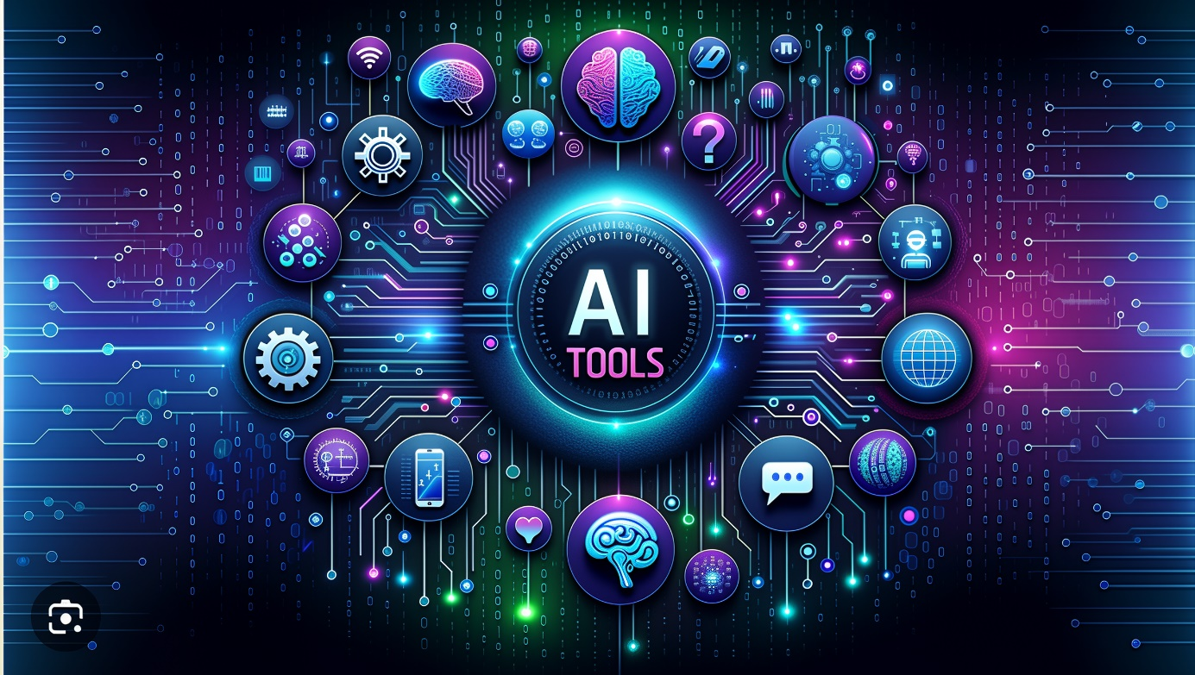

4. Technical and Ethical Challenges in Agent Deployment
The deployment of autonomous AI agents is not without significant challenges. These can be broadly divided into technical hurdles, which impact reliability and safety, and ethical risks, which impact society and trust.

4.1. Technical Hurdles: Reliability, Scalability, and Security
A primary technical challenge is reliability and predictability. LLM-based agents can still "hallucinate" or generate plausible but incorrect reasoning chains, leading to faulty actions that are difficult to anticipate (Huang et al., 2023). Ensuring that an agent reliably follows complex, multi-step instructions without deviation remains an open research problem. Scalability is another concern; as agents take on more critical roles, the computational resources required for their operation can become immense. Furthermore, AI agents introduce new cybersecurity vulnerabilities. A malicious actor could potentially "jailbreak" an agent's instructions to perform unauthorized actions or manipulate its perceptual input to cause harmful behavior, a risk known as prompt injection. The OECD (2024) has flagged the security and integrity of AI systems as a primary concern for policymakers.
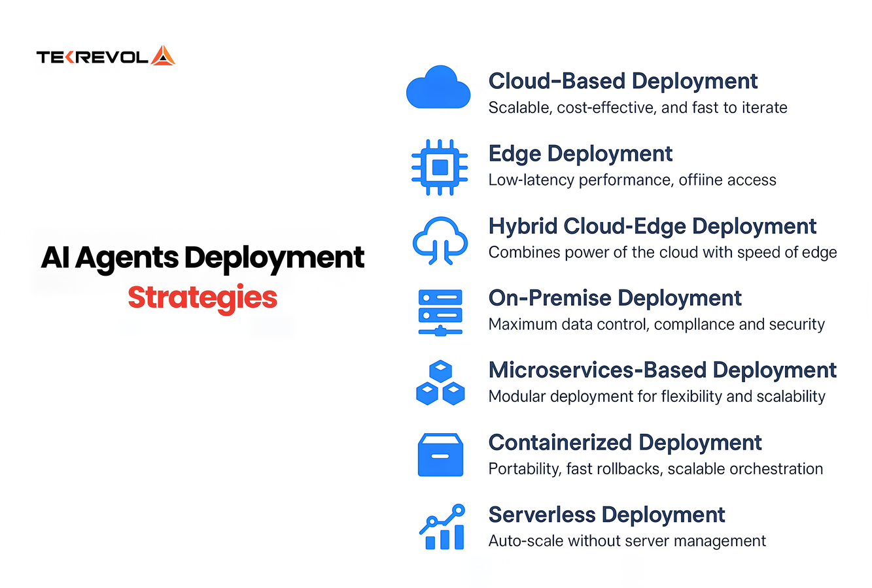

4.2. Ethical Risks: Accountability, Bias, and Societal Impact
The autonomous nature of AI agents complicates traditional notions of accountability. When an AI agent causes harm—for example, making an erroneous financial trade or disseminating illegal content—determining legal liability is complex. The "responsibility gap" asks whether blame falls on the developers, the users, the deployers, or the agent itself (Taeihagh, 2021). Moreover, agents can inherit and amplify societal biases present in their training data, potentially automating and scaling discrimination in areas like hiring or loan applications. On a macroeconomic scale, the widespread adoption of agentic automation could lead to significant labor market disruption, displacing roles in administrative, creative, and even analytical fields. This necessitates a serious discussion about economic transition and reskilling.

5. Governance Frameworks and Recommendations for Safe Deployment
To harness the benefits of AI agents while mitigating their risks, a multi-faceted approach combining technical measures, ethical guidelines, and regulatory oversight is essential.

5.1. Emerging Technical and Regulatory Standards
From a technical standpoint, the principle of human-in-the-loop (HITL) is critical, especially for high-stakes decisions. This involves designing systems where humans can monitor, approve, or override an agent's critical actions. Agent transparency and interpretability are also crucial; developers must build mechanisms that allow agents to explain their reasoning and actions in human-understandable terms. From a regulatory perspective, frameworks like the NIST AI Risk Management Framework and the EU's AI Act provide foundational guidance. These frameworks advocate for a risk-based approach, where applications posing greater potential harm are subject to more stringent requirements for testing, transparency, and human oversight (NIST, 2023).
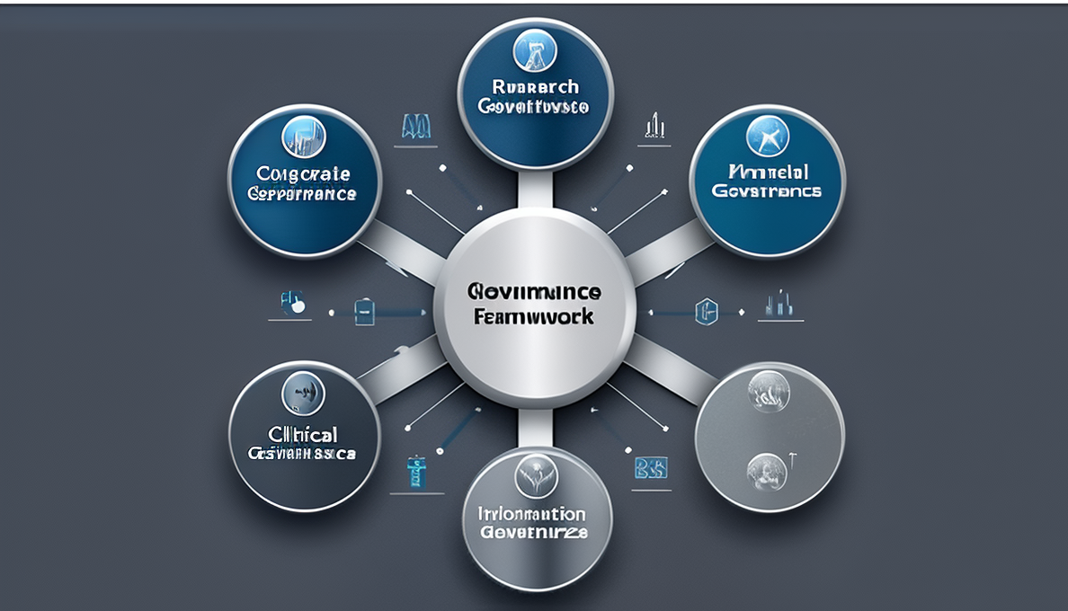

5.2. A Multi-Stakeholder Path Forward
Effective governance requires collaboration among all stakeholders. Policymakers should focus on establishing clear, adaptable regulations that ensure safety without stifling innovation. Industry leaders must commit to rigorous testing, red-teaming, and the development of safety-focused best practices. Academic and research institutions have a vital role in advancing the core research on AI alignment and safety. Finally, public awareness and education are necessary to foster a society that is both critically engaged and equipped to interact with these powerful technologies.

6. Conclusion
AI agents represent a transformative leap in artificial intelligence, shifting the paradigm from passive tools to active, goal-directed partners. Their architectures, which integrate perception, reasoning, and action, enable a vast range of applications that promise to boost productivity, accelerate innovation, and simplify daily life. However, this potential is coupled with profound technical and ethical challenges, including issues of reliability, accountability, bias, and societal disruption. Navigating this new landscape successfully requires a proactive and collaborative effort. By implementing robust technical safeguards, adhering to ethical principles, and developing thoughtful, adaptive regulations, society can steer the development of AI agents toward outcomes that are not only efficient but also safe, equitable, and beneficial for all.

7. Limitations and Further Research
This report provides a high-level overview, and its analysis is constrained by several limitations. The field of AI agents is evolving at an extraordinary pace, meaning that new architectures and capabilities are emerging faster than they can be formally studied and documented. The assertions regarding future economic impact, while based on current trends, are inherently uncertain and would require longitudinal primary research to validate. Further research is critically needed in several areas: developing more reliable and verifiable agent reasoning processes, creating standardized benchmarks for agent safety and robustness, and formulating concrete legal frameworks to address the accountability gap for autonomous actions.

8. References
Huang, J., Gu, S. S., Hou, L., Wu, Y., Wang, X., Yu, H., & Han, J. (2023). Large Language Models Can Self-Improve. arXiv preprint arXiv:2310.01733. https://arxiv.org/abs/2310.01733
McKinsey Global Institute (MGI). (2023). The economic potential of generative AI: The next productivity frontier. McKinsey & Company. https://www.mckinsey.com/capabilities/mckinsey-digital/our-insights/the-economic-potential-of-generative-ai-the-next-productivity-frontier
National Institute of Standards and Technology (NIST). (2023). AI Risk Management Framework (AI RMF 1.0). U.S. Department of Commerce. https://www.nist.gov/itl/ai-risk-management-framework
Organisation for Economic Co-operation and Development (OECD). (2024). OECD AI Policy Observatory. https://oecd.ai/
Russell, S., & Norvig, P. (2020). Artificial Intelligence: A Modern Approach (4th ed.). Pearson.
Taeihagh, A. (2021). Governance of artificial intelligence. Policy and Society, *40*(2), 137–157. https://doi.org/10.1080/14494035.2021.1928377
Wang, L., Xu, W., Lan, Y., Hu, Z., Lan, Y., Lee, R. K.-W., & Lim, E.-P. (2023). Plan-and-Solve Prompting: Improving Zero-Shot Chain-of-Thought Reasoning by Large Language Models. arXiv preprint arXiv:2305.04091. https://arxiv.org/abs/2305.04091
Xi, Z., Chen, W., Guo, X., He, W., Ding, Y., Hong, B., Zhang, M., Wang, J., Jin, S., Zhou, E., Zheng, R., Fan, X., Wang, X., Xiong, L., Zhou, Y., Wang, W., Jiang, C., Zou, Y., Liu, X., & Yin, D. (2023). The Rise and Potential of Large Language Model Based Agents: A Survey. arXiv preprint arXiv:2309.07864. https://arxiv.org/abs/2309.07864

